Data Warehousing Assignment 2
Student Name: Sumandeep Kaur

Table of Contents
1. TASK1 – Data Integration (ETL) and Maintenance 4
1.1 Original datasets 4
Data Set Loading in APEX: 4
Data Loaded in APEX 5
Data Extraction Creating Table 5
Dataset Loaded Successfully 6
1. SCREEN SHOT (new database schema) 6
Creating a table (DRUGS) 7
Table Data entries & data type view 7
2nd DB CRIME TYPE 8
SQL Workshop Commands History 8
Evidence Code 9
1.2 Star Schema 9
Fact Table 10
Crime register 10
Crime reporting table 11
Aggregate Function in APEX 11
1.3 Staging Area 14
Data Dictionary Table 15
1.3.1 Extracting of data into a temp table? 15
Schema comparison 16
Cleaning of data 17
Crime dataset table followed by dataset 17
Application for checking & verifying dataset 17
Transforming of data 18
ETL SCRIPT IN APEX 18
Evidence code 19
Loading data into SS 19
Assumptions & Discussion 20
Model of Fact Table 21
Fact table 21
How will you populate your Time Dim? 22
Evidence Code 22
Discussion 23
2. TASK 2 - OLAP 24
PIVOT Table & Data Warehousing Query 24
Excel Pivot Table 24
Fact Table 25
Dimension Table 25
OLAP Operation 26
OLAP Processing by describing 26
PIVOT Table in Excel 27
Database Tables in MS Access 27
Relationship mapping in Ms Access 28
PIVOT in EXCEL 28
Literature Review 29
Methodology 29
Architecture 30
PAPA framework, Theory of Stakeholders 30
Bibliography 31
Appendixes – add of your APEX code here 33
SQL Query Scripts 33

TASK1 – Data Integration (ETL) and Maintenance

1.1 Original datasets
Answer:
- Workspace Name: c7263731
- User Name: c7263731
- Password : Manreet1
Creating a New Schema (Name Data warehouse)

Data Set Loading in APEX:

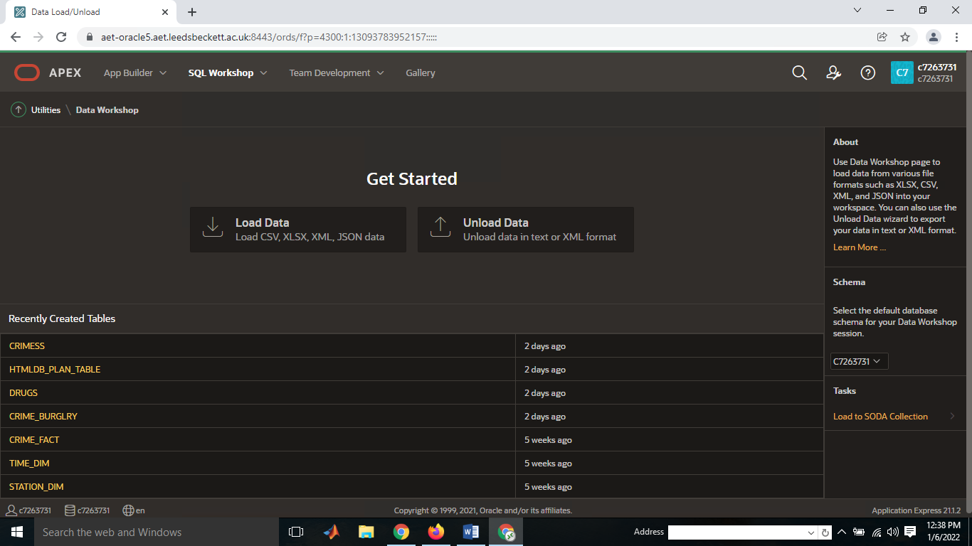

Data Loaded in APEX

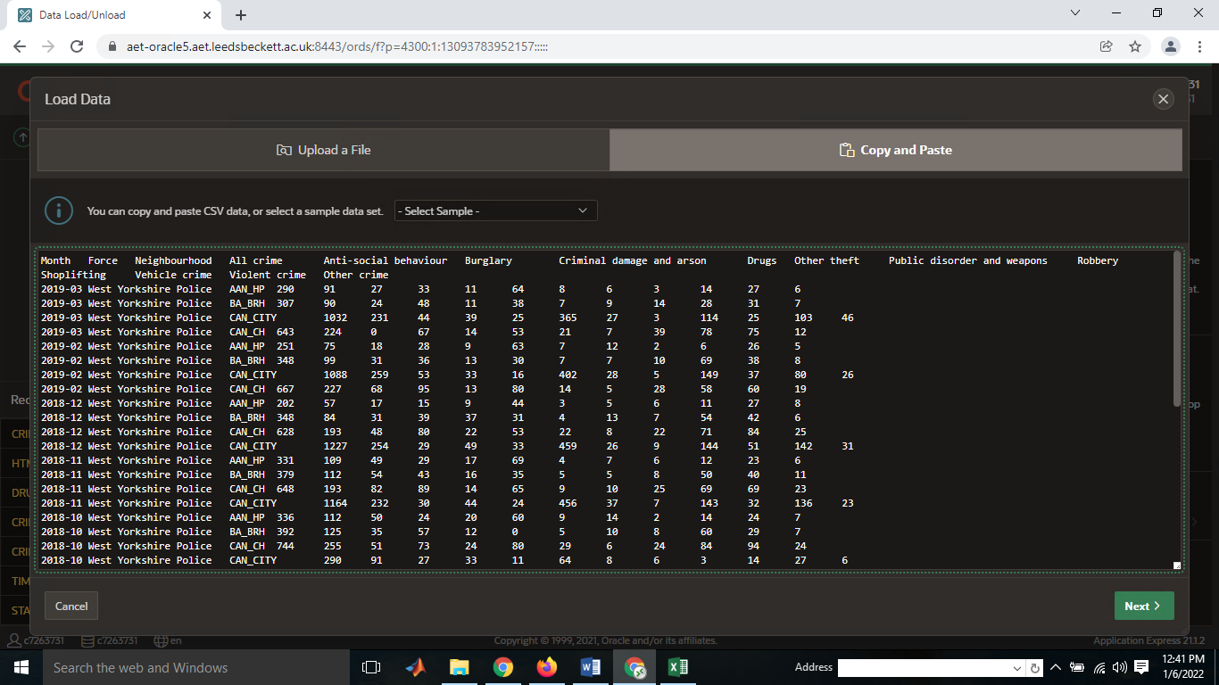

Data Extraction Creating Table

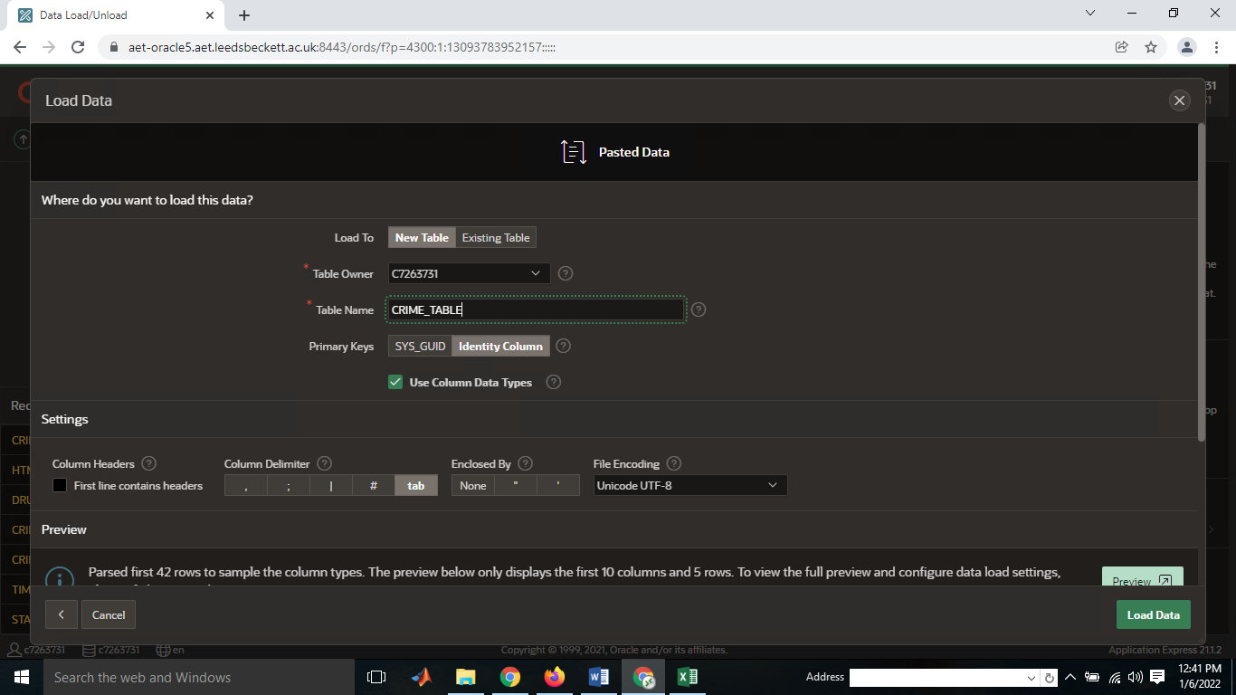

Dataset Loaded Successfully



SCREEN SHOT (new database schema)

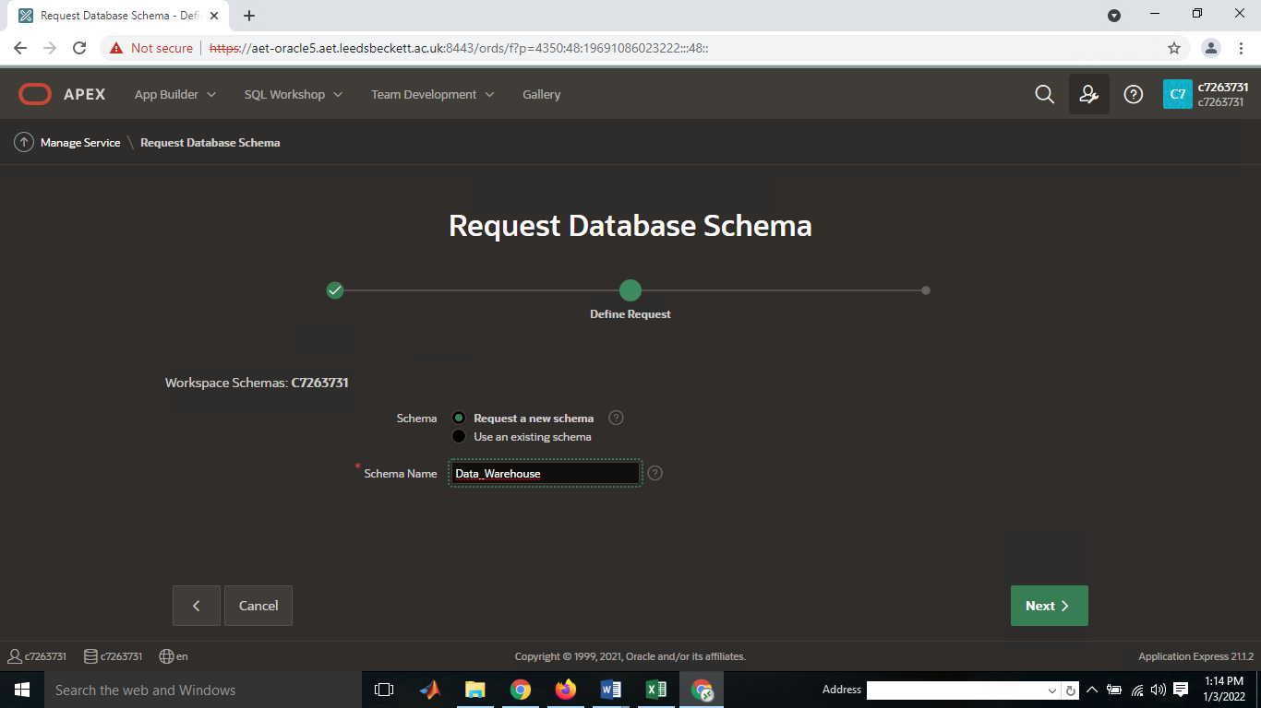

Creating a table (DRUGS)
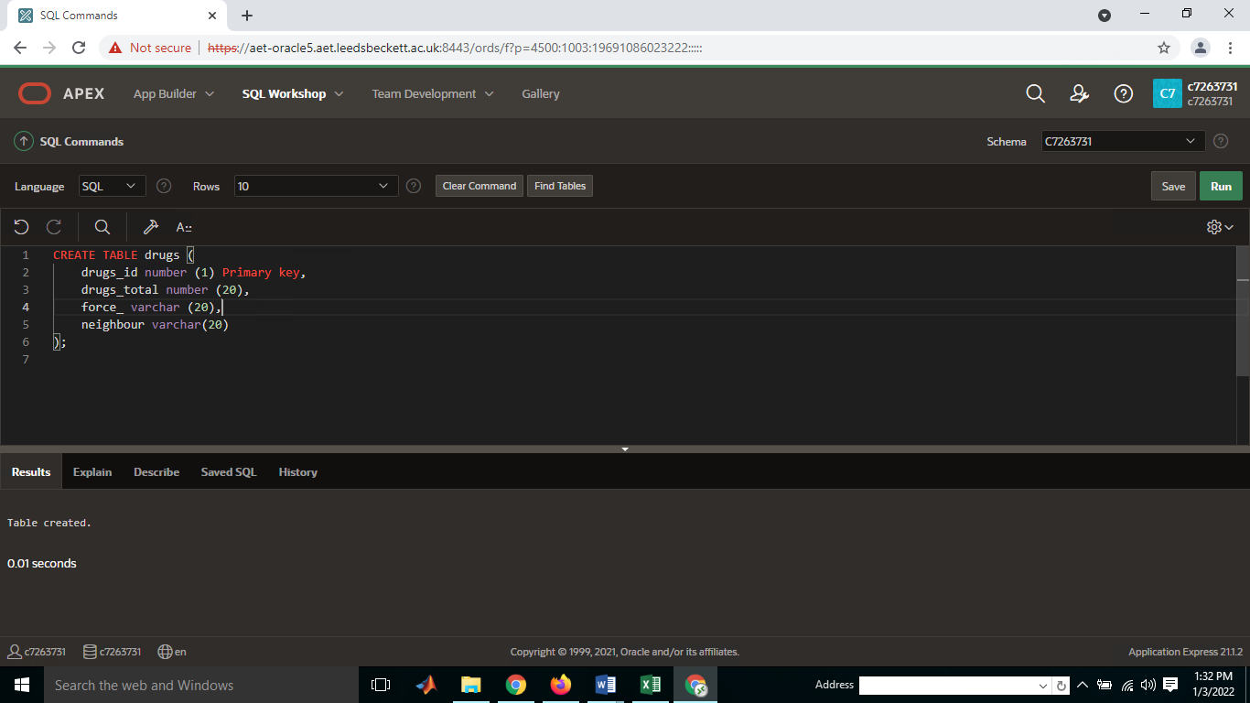

Table Data entries & data type view
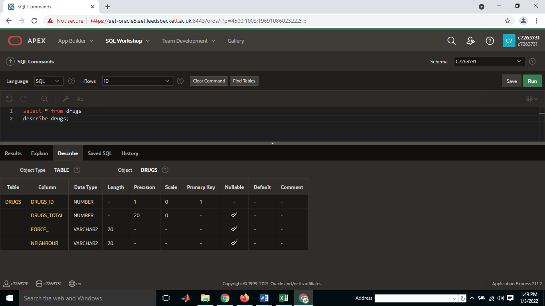

2nd DB CRIME TYPE
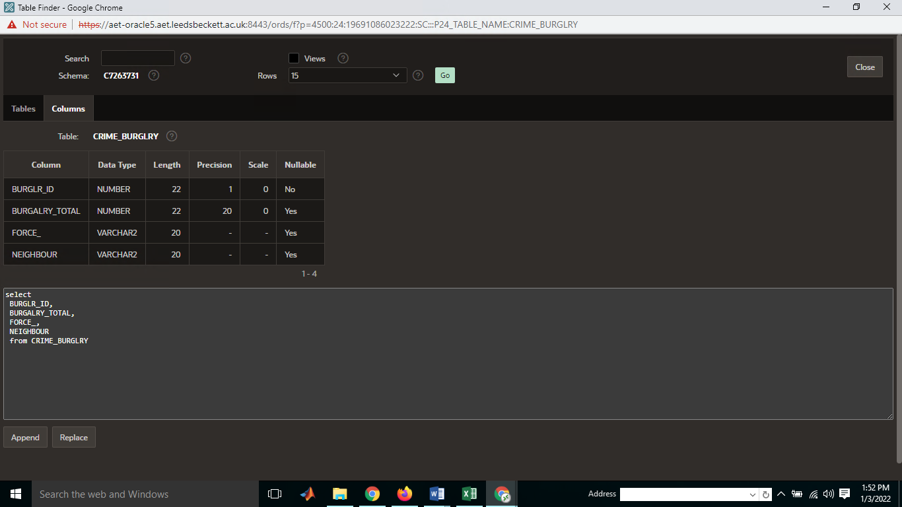

SQL Workshop Commands History

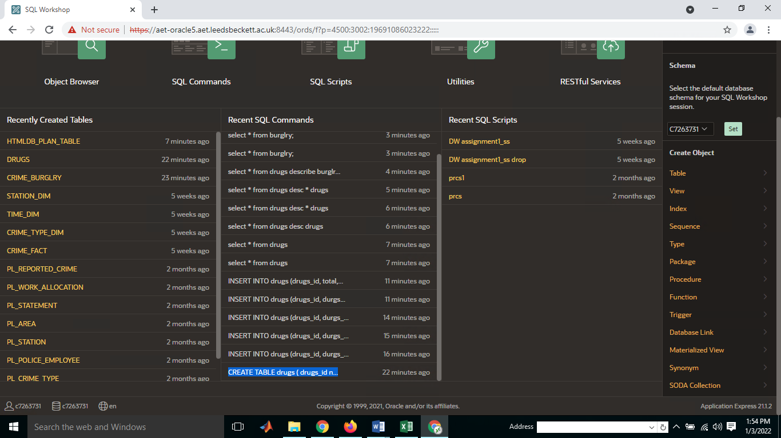

Evidence Code

1.2 Star Schema
- Have the diagram of your SS here.

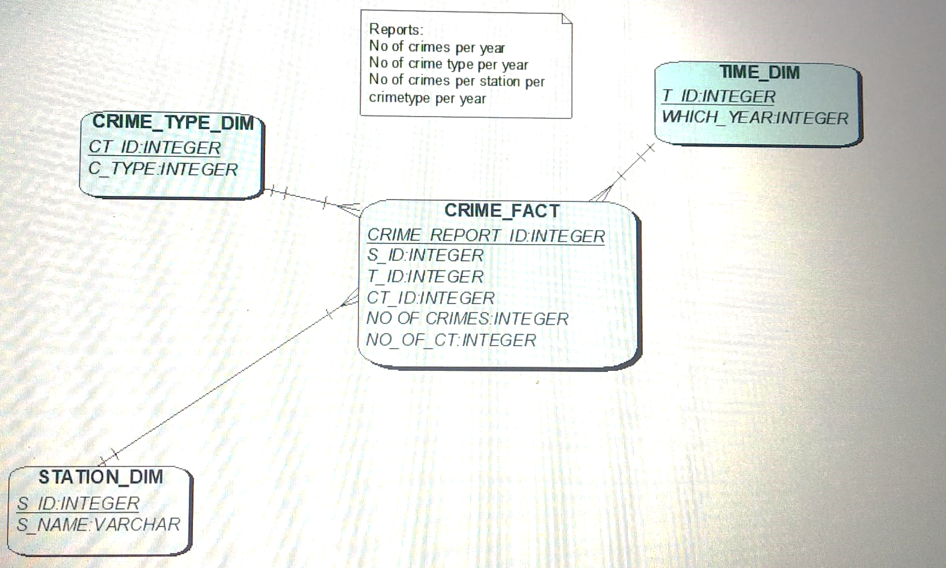

Fact Table

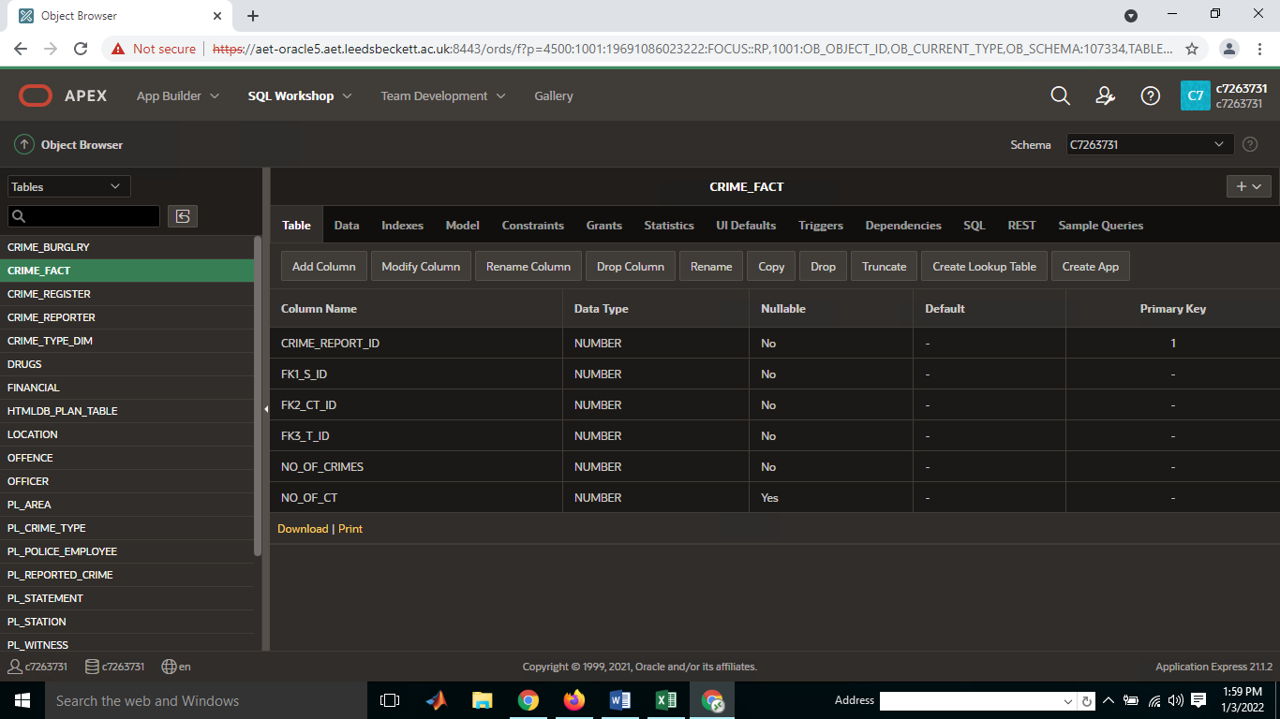

Crime register
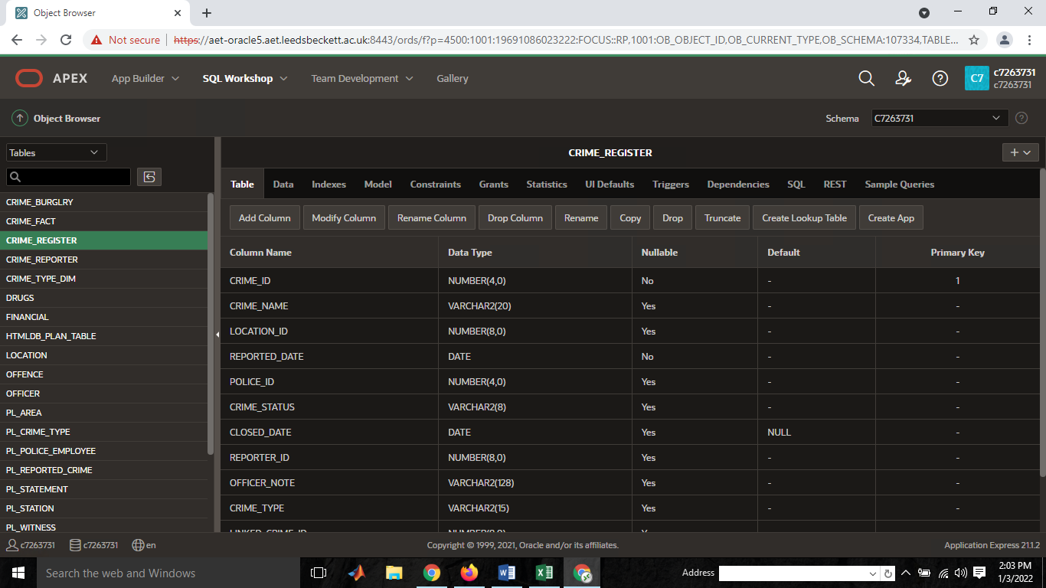

Crime reporting table
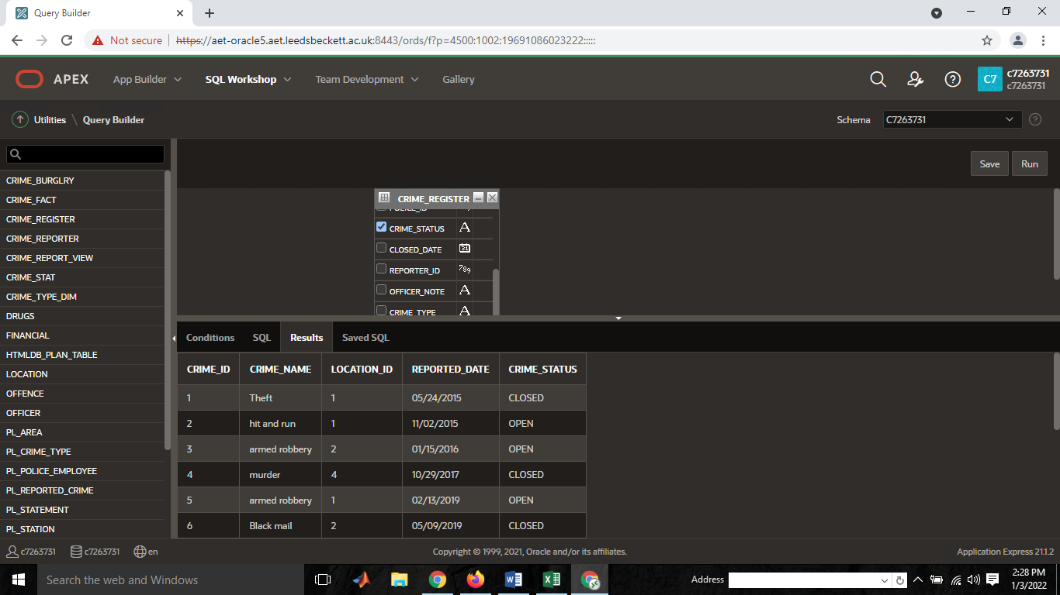

Aggregate Function in APEX
- Count()
- Sum()
- AVG()
- Max()
- MIN()
First COUNT () is applied on crime register table as follows:
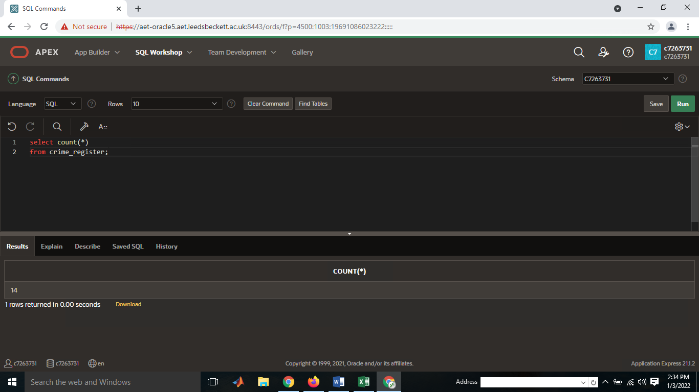
SUM ()
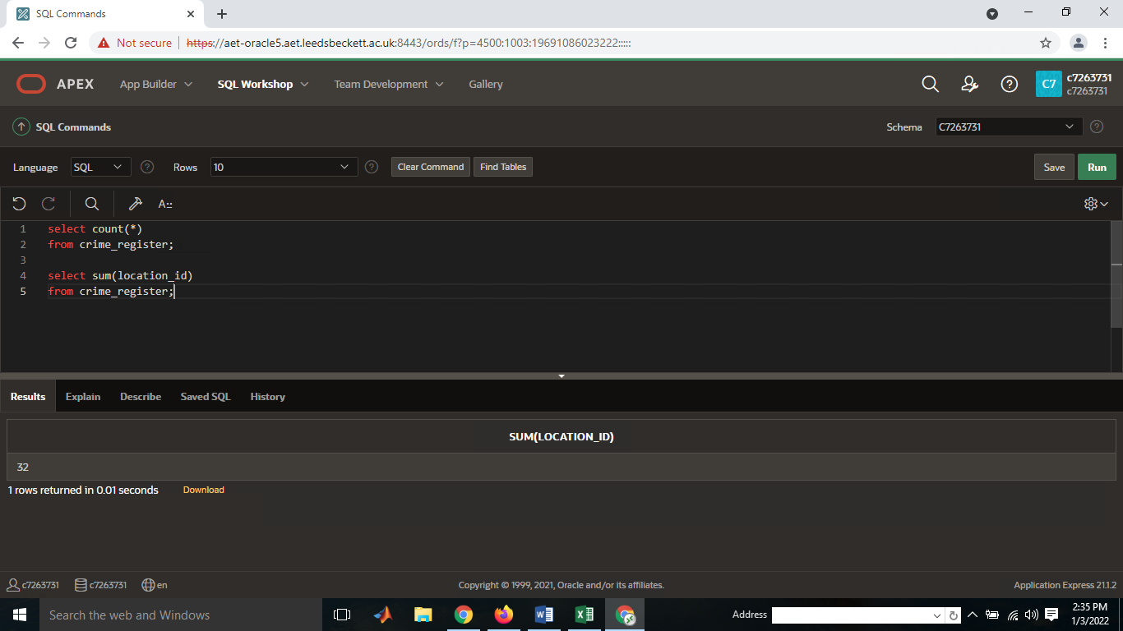

AVG ()
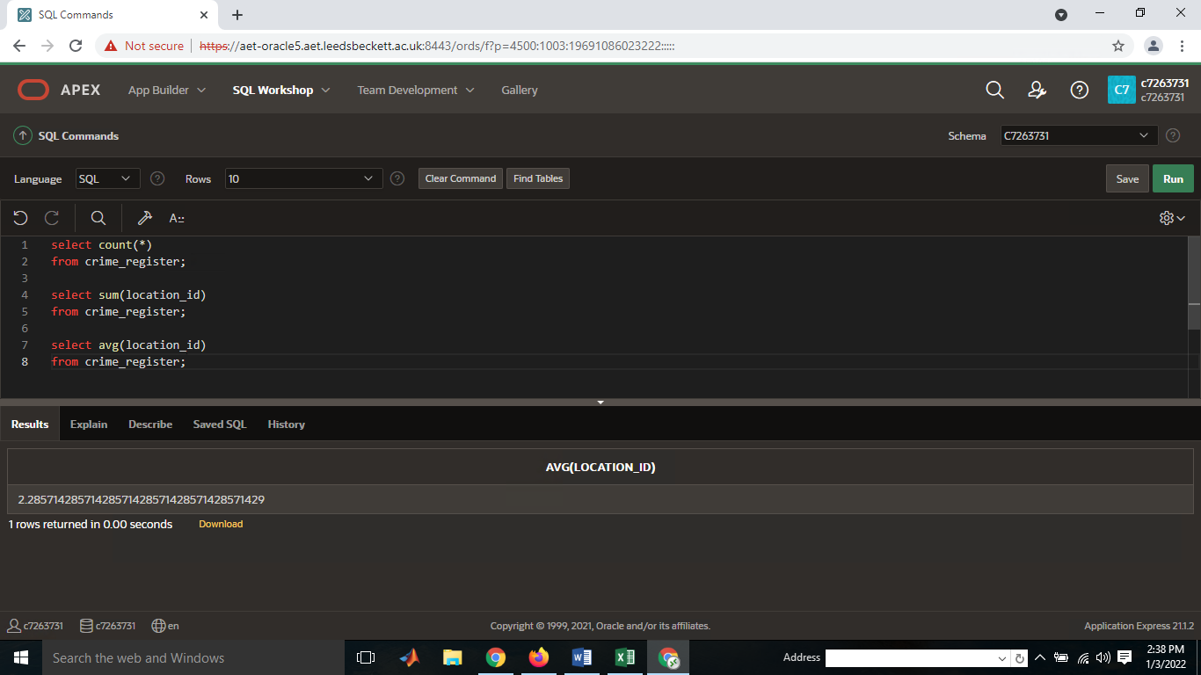

MAX ()
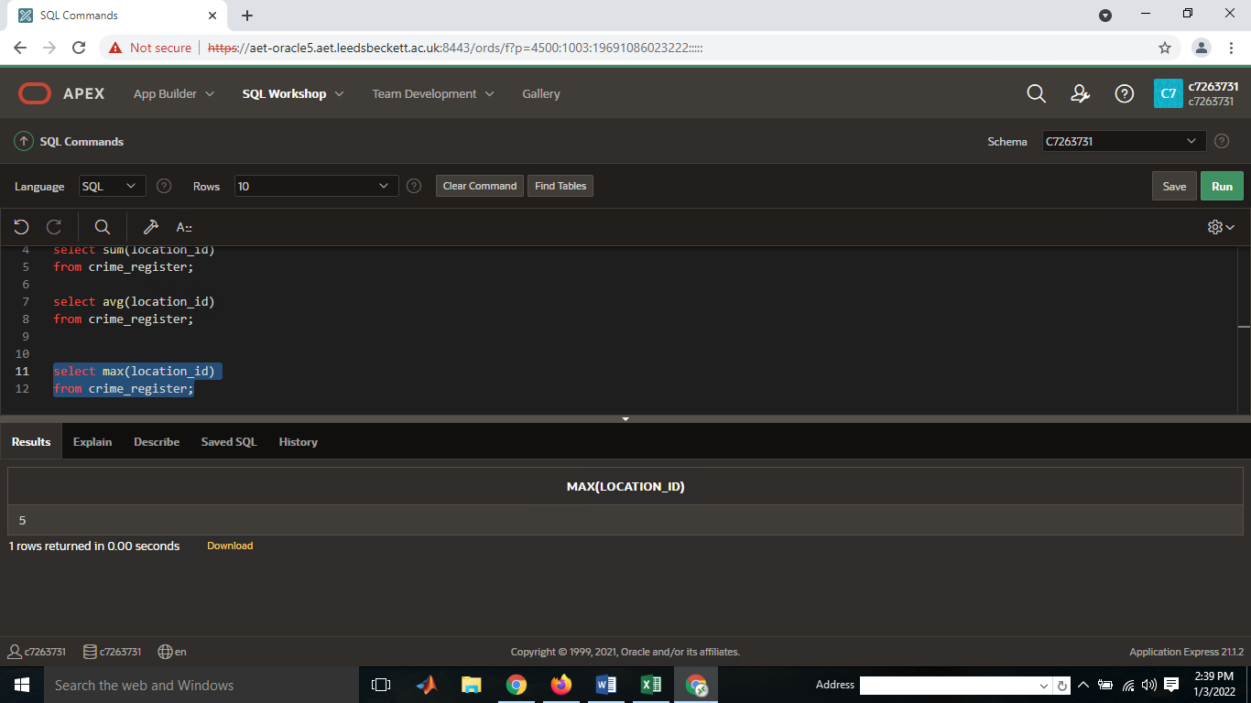

MIN ()
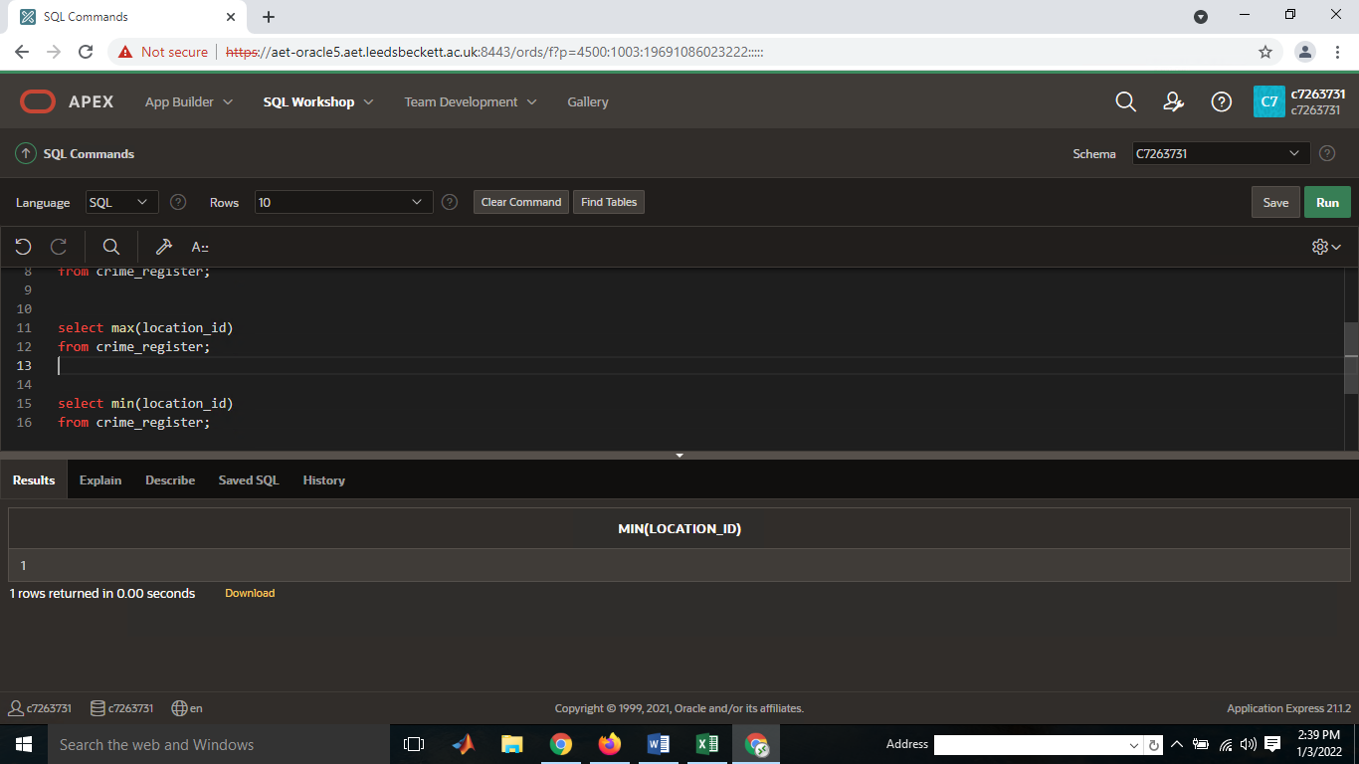
Answer: star schema based on fact table, mostly the fact tables stores the foreign keys of other associated table in it. All associated table has been directly implemented and associated with fact table.
in assignment the data dictionary table prepared in excel sheet which present the data types and data size of the attribute of the table.
Star schema created in excel as well which present the fact table and other associated table , related with fact table entries.

Select count(*)
from crime_register;

Select sum(location_id)
from crime_register;
select avg(location_id)
from crime_register;

select max(location_id)
from crime_register;
select min(location_id)
from crime_register;

Staging Area

Answer: in this project I am considering Excel sheet instead of using tableau, excel worksheet presented well in order to create star schema and other related table with data dictionary.

Data Dictionary Table

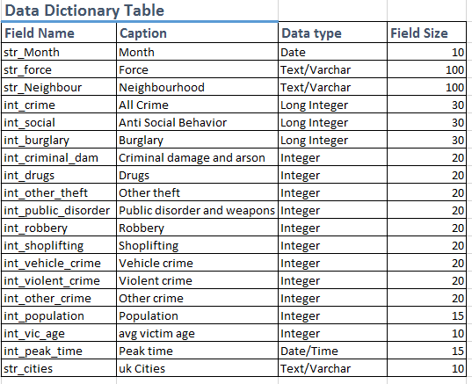

Extracting of data into a temp table?

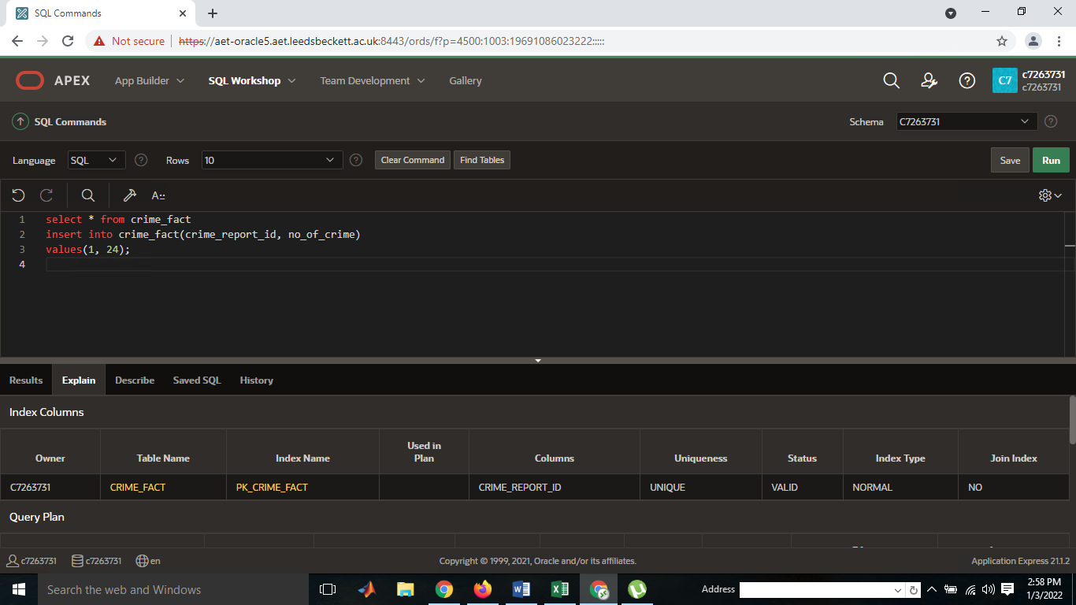
OR
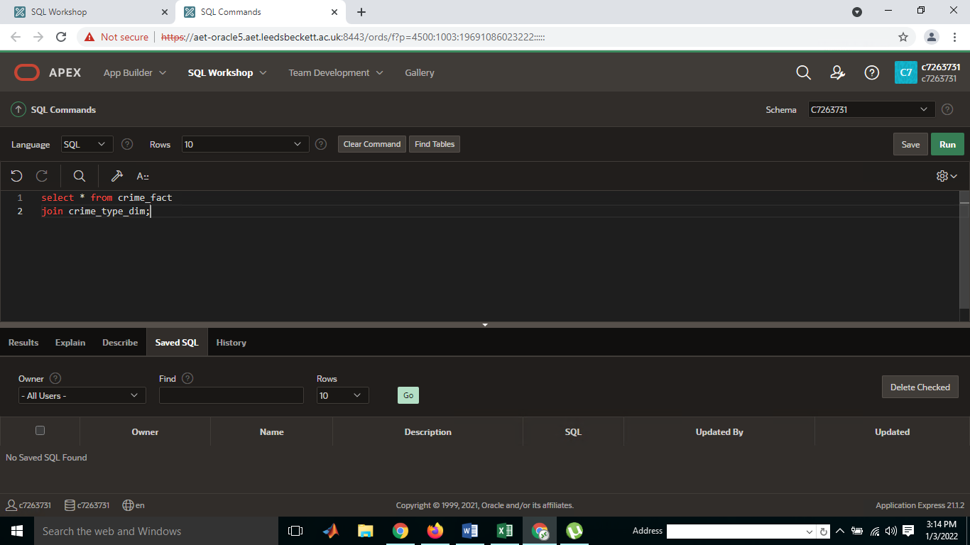

Schema comparison

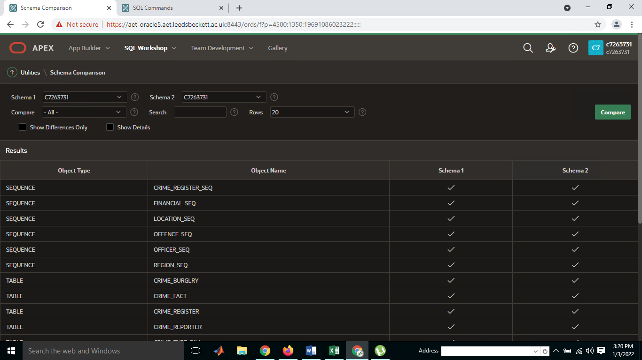

Cleaning of data
Answer: the crime dataset has been provided, there is no missing value and missing attribute.
Data is presented in data dictionary table followed by the data types and data item of interest.
Newly created table with dataset including all entries with no missing and no error appear in the dataset uploading and views.

Crime dataset table followed by dataset
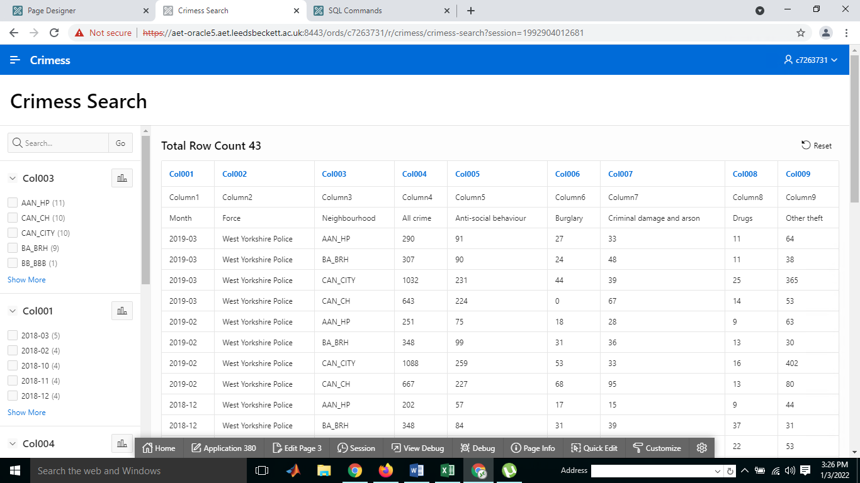

Application for checking & verifying dataset

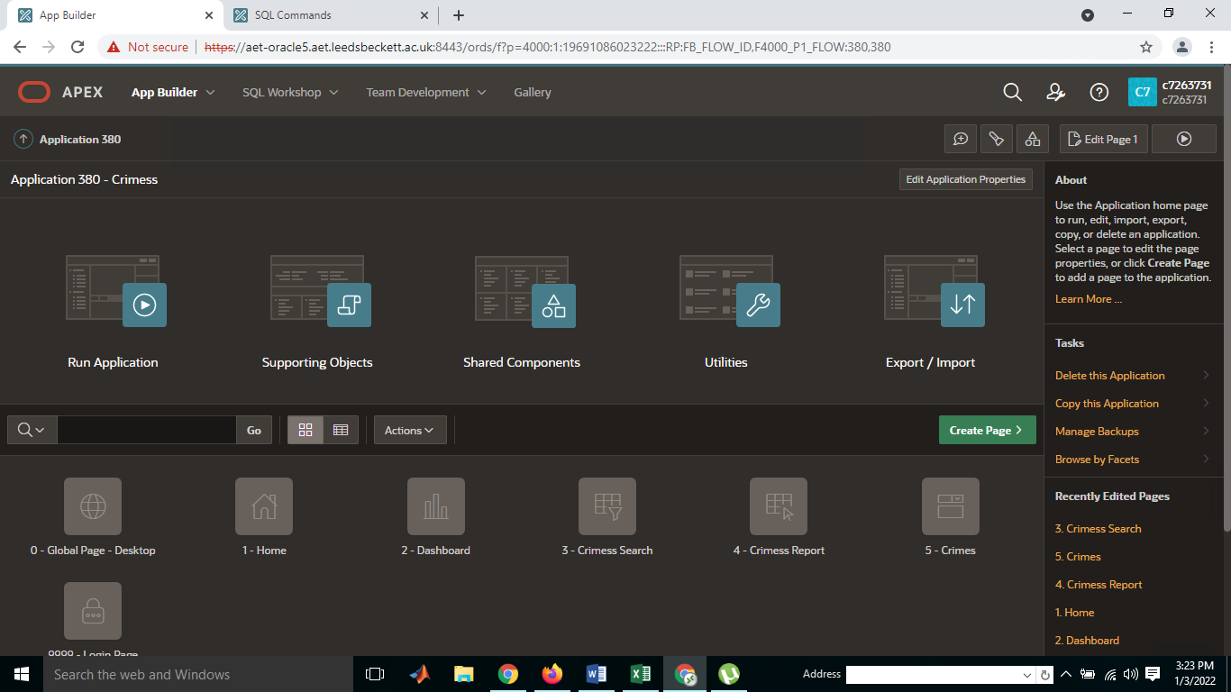

Transforming of data
- Design this ETL script. Have all considerations in a table.
Answer:
(Rahm, E. Do, H.H., 2000) classify the quality of data, for cleaning the dataset is always considering a challenging part, in which various issues and problem has been addressed. Data cleaning when required when there is large amount of heterogeneous data is available. So there is need to improve the dataset efficiently and removing the unwanted rows and unwanted columns
In data cleaning removing the NA and NAN values in the dataset, in data warehousing dataset need to be cleared and precise , repeating values removed and only manage the data attributes with original value.

ETL SCRIPT IN APEX



Evidence code

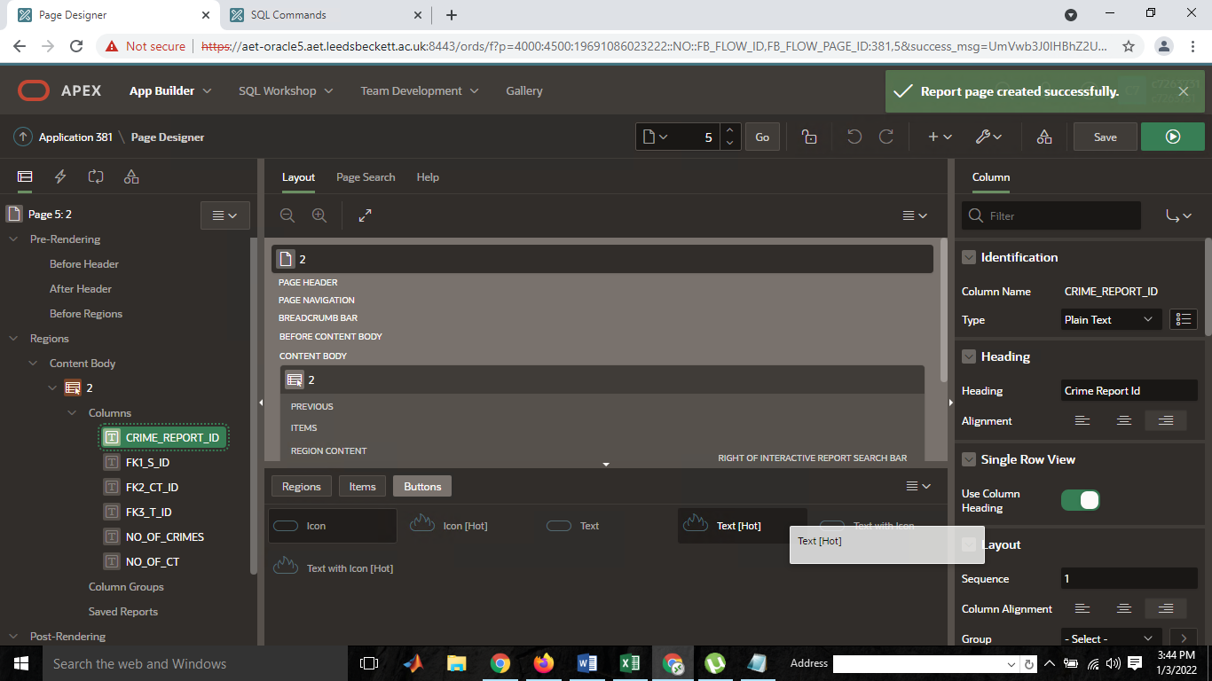

Loading data into SS
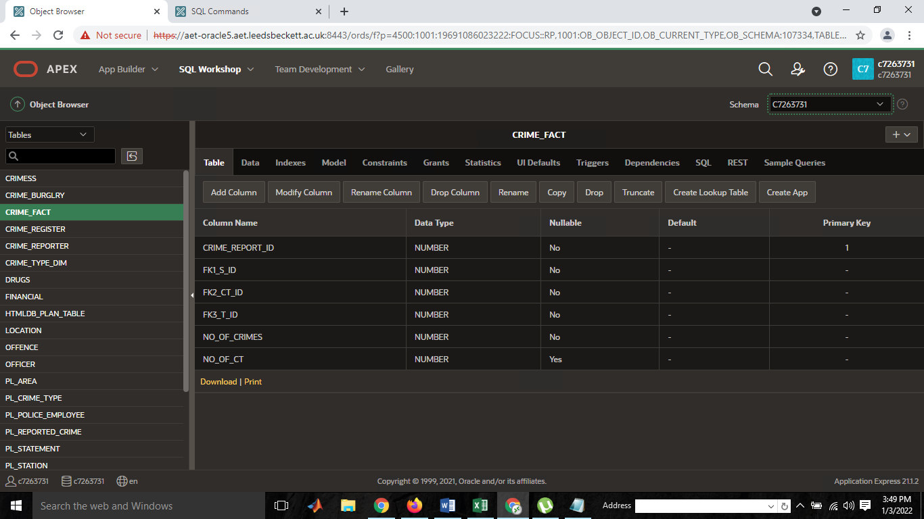
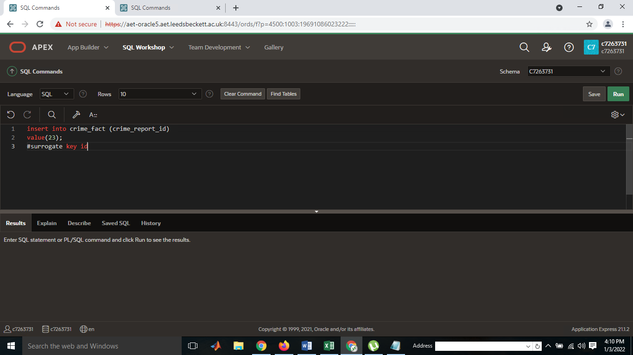

Assumptions & Discussion

(Inmon, W.H., 1995) data warehousing was consider subject oriented and goal oriented approach to update & verify the time variant in the data dimensional table, most the data dictionary helps to generate the fact table and other associated data relational data in the database system. Data warehousing is large database processing unit system that extract, transform and load data attribute form different data sources based on the fact table of the organization. The relational schema of database works efficiently to manage and optimize the complex query operation on different source and destination locations.

Model of Fact Table
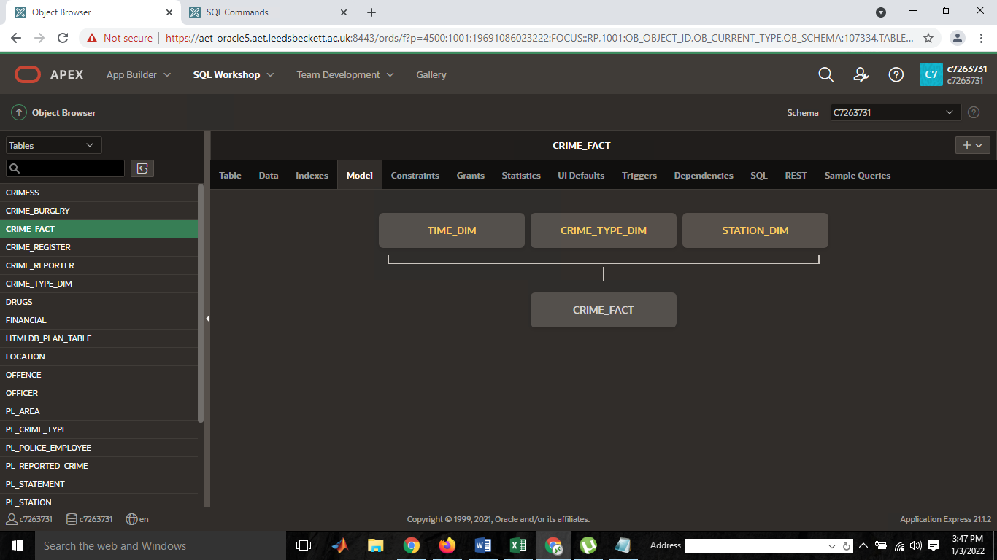

Fact table

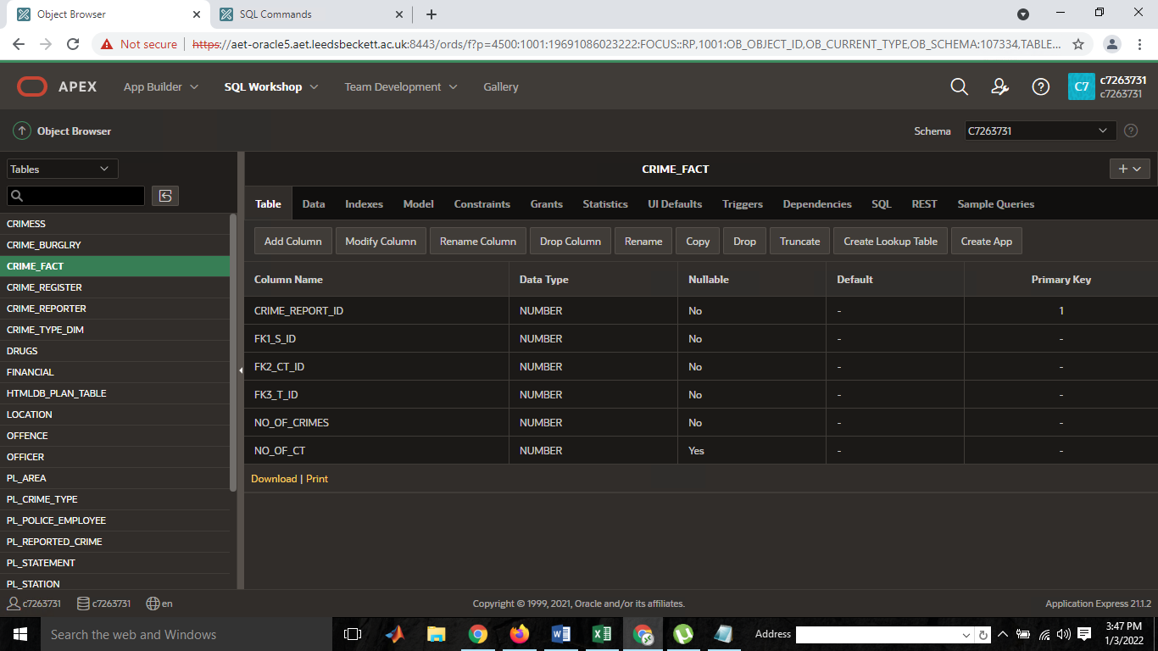

How will you populate your Time Dim?

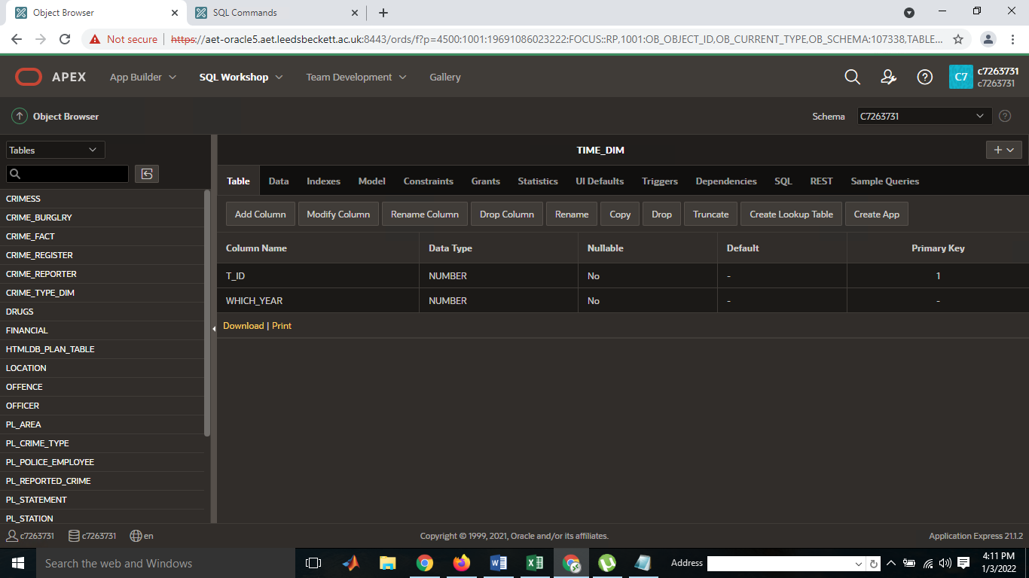

Evidence Code
CREATE OR REPLACE EDITIONABLE TRIGGER "CRIME_REGISTER_TRIG"
BEFORE INSERT ON CRIME_REGISTER
FOR EACH ROW
BEGIN
IF :NEW.CRIME_id IS NULL THEN
SELECT CRIME_REGISTER_SEQ.NEXTVAL INTO :NEW.CRIME_ID FROM SYS.DUAL;
END IF;
END;

/
ALTER TRIGGER "CRIME_REGISTER_TRIG" ENABLE
/ CREATE TABLE "CRIME_TYPE_DIM"
( "CT_ID" NUMBER(*,0) NOT NULL ENABLE,
"C_TYPE" NUMBER(*,0) NOT NULL ENABLE,
CONSTRAINT "PK_CRIME_TYPE_DIM" PRIMARY KEY ("CT_ID")
USING INDEX ENABLE
)
/ CREATE TABLE "CRIME_BURGLRY"
( "BURGLR_ID" NUMBER(1,0),
"BURGALRY_TOTAL" NUMBER(20,0),
"FORCE_" VARCHAR2(20),
"NEIGHBOUR" VARCHAR2(20),
PRIMARY KEY ("BURGLR_ID")
USING INDEX ENABLE
)

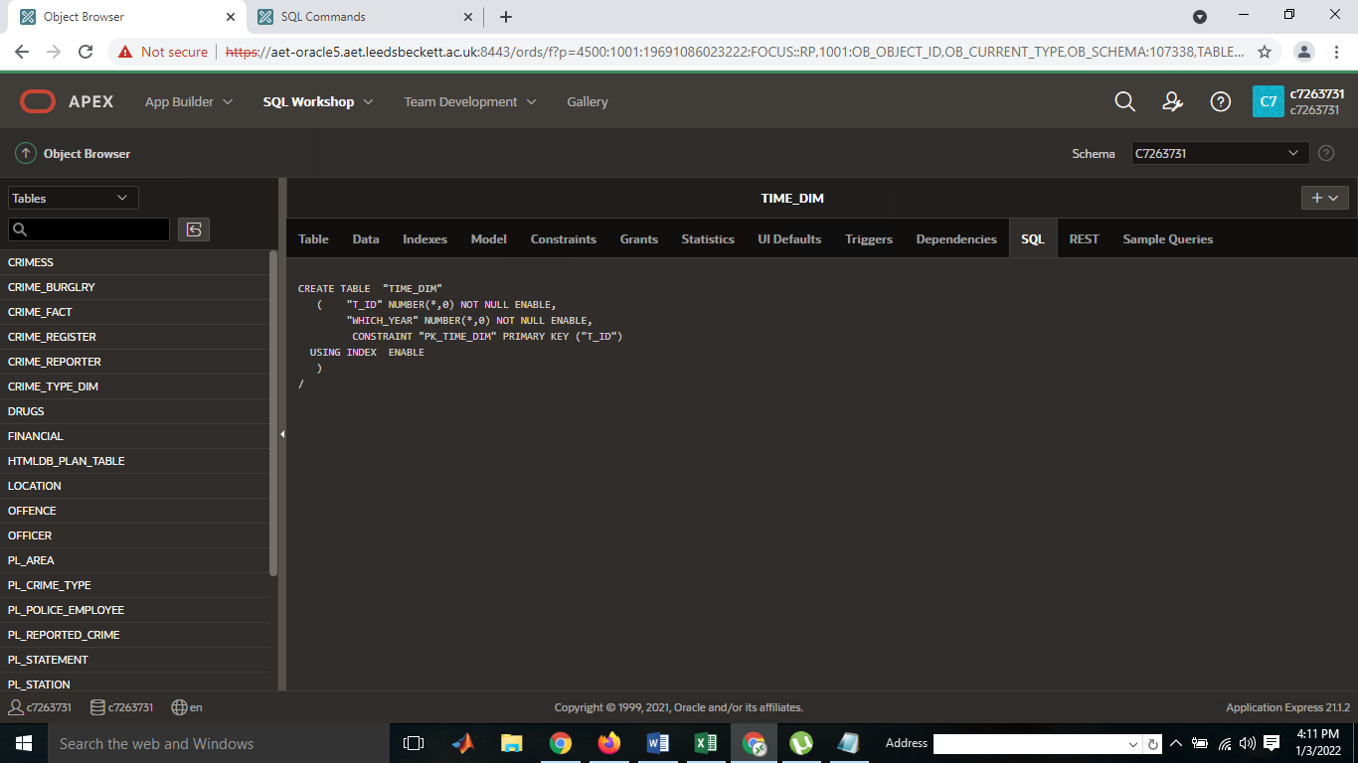

Discussion
(Golab, L., Johnson, T., Seidel, 2009,) data warehousing generates the ETL script based statement view in order the process the query operation into the data warehousing projection. Data stream management system operate and verify the objects of internal fact table attribute. The similar data stream management system operate the associated table entries and operate the internal operation to check and verify the data integration operation. The real time data stream operation updated and verified on queries processing operating and on demand queries has been operated on request stream object. In data warehousing projections various largest queries operation has been processed and operate on data warehousing projection (Eckerson, W.W., 2002.) data quality depends on the data types and attributes association with the fact table, each id is connected with fact table to produce the associated query operation. The contribution of this report is going to investigate and interpret the resultant values based on the user choice and needs. The user query choice operation has been extracted load and integrate on the data dependent value.
1.3.5 Ongoing Data Load (Data Maintenance (SCD)) implemented and evidenced as part to the solution.

TASK 2 - OLAP

PIVOT Table & Data Warehousing Query
(Gao, B., Zhang, Yao, N., 2012) in data warehousing mostly the data mining algorithm works to refine and extract the exact query required by the client and user of the organization, in data extraction and loading method the pivot table helps lot to generate and extract the query as per the on demand and requested by the client. The multi-dimensional model of data warehousing, data warehousing and OLAP provides the powerful method to process the complex query operated by the various source and destinations locations. The effective means of data dimensional object test and train the excel dataset and validate the result based on the testing training purposes. Pivot table approach previously applied by various data center to process and manage the query operation. In web based query extraction feature has been very poor and not good because of query processing time takes time while operate the query online method.

Excel Pivot Table
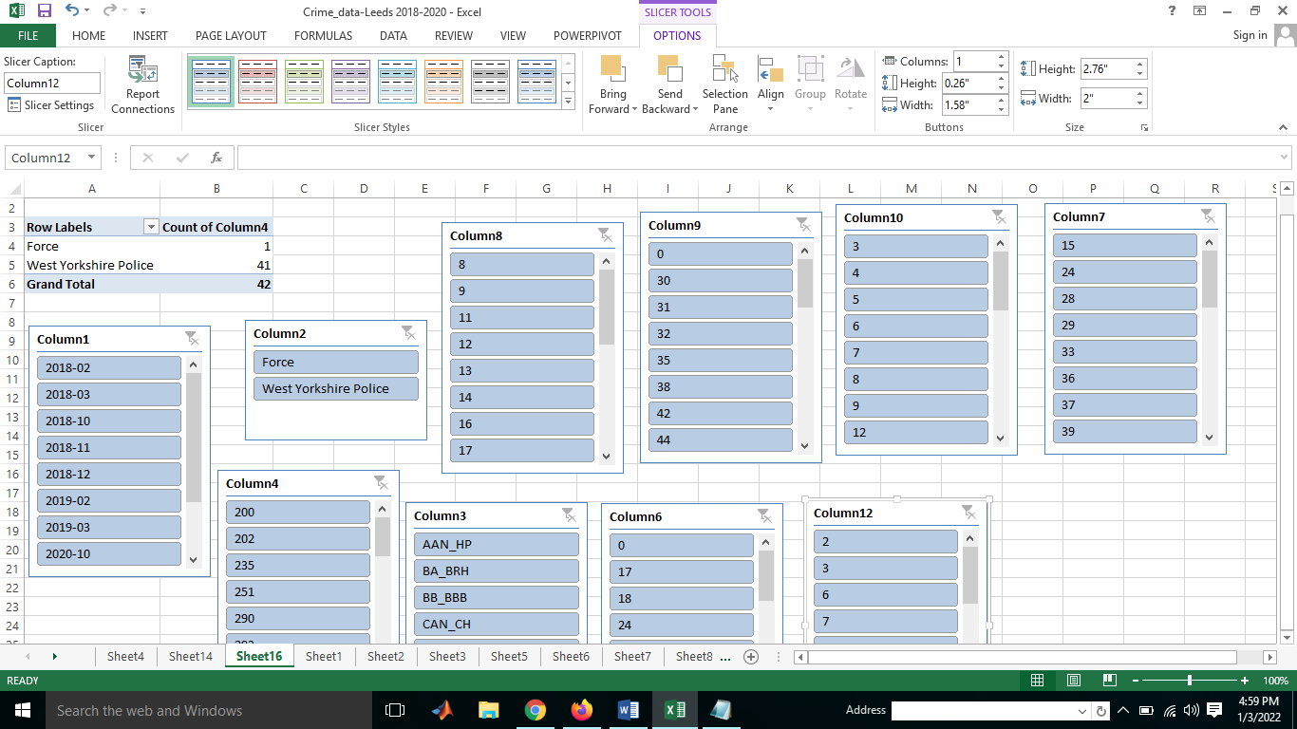

Fact Table
Attribute Name | Data type | Size | Foreign key (Dimension table) | Data type | size
CriminalReportID (PK) | Integer | 10 | CriminalReportID (PK) | Integer | 10
S_id | Integer | 10 | S_id (FK) | Integer | 10
T_ID | Integer | 10 | T_ID(FK) | Integer | 10
CT_ID | Integer | 10 | CT_ID(FK) | Integer | 10
NO_OF_CRIMES | Integer | 10 | NO_OF_CRIMES(FK) | Integer | 10
NO_Of_CT | Integer | 10 | NO_Of_CT(FK) | Integer | 10
 |  |  | All_Criminal_ID (FK) | Integer | 10

Dimension Table

Crime TYPE DIM
Attribute Name | Data type | Size
C_ID | Integer | 10

TIME_DIM
Attribute Name | Data type | Size
T_ID | Integer | 10

STATION_DIM
Attribute Name | Data type | Size
T_ ID | Integer | 10

OLAP Operation

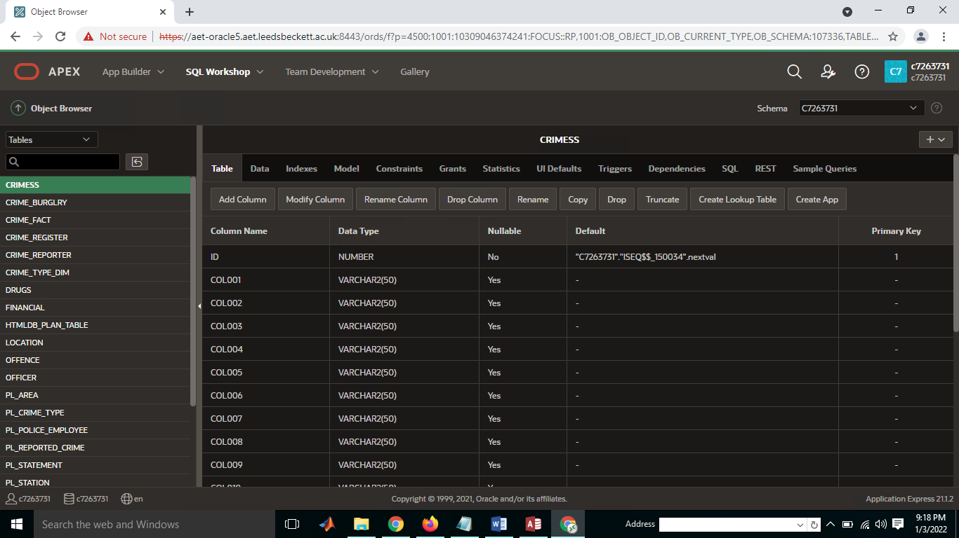

OLAP Processing by describing
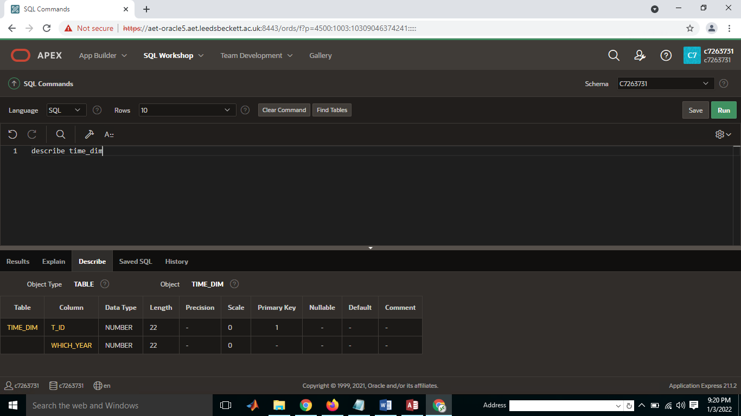

PIVOT Table in Excel
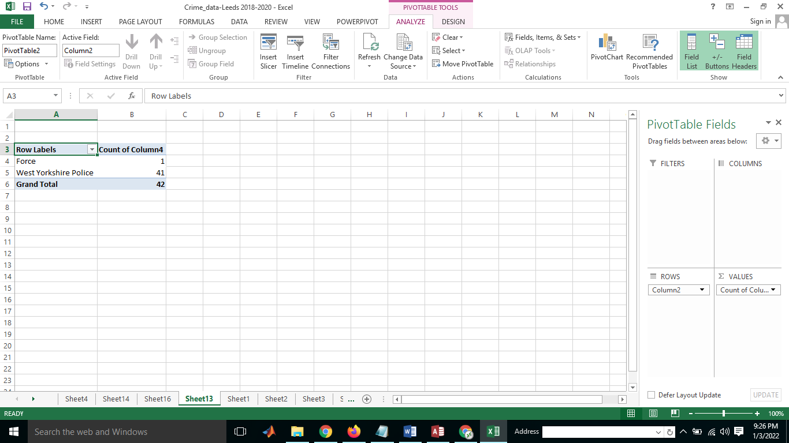

Database Tables in MS Access
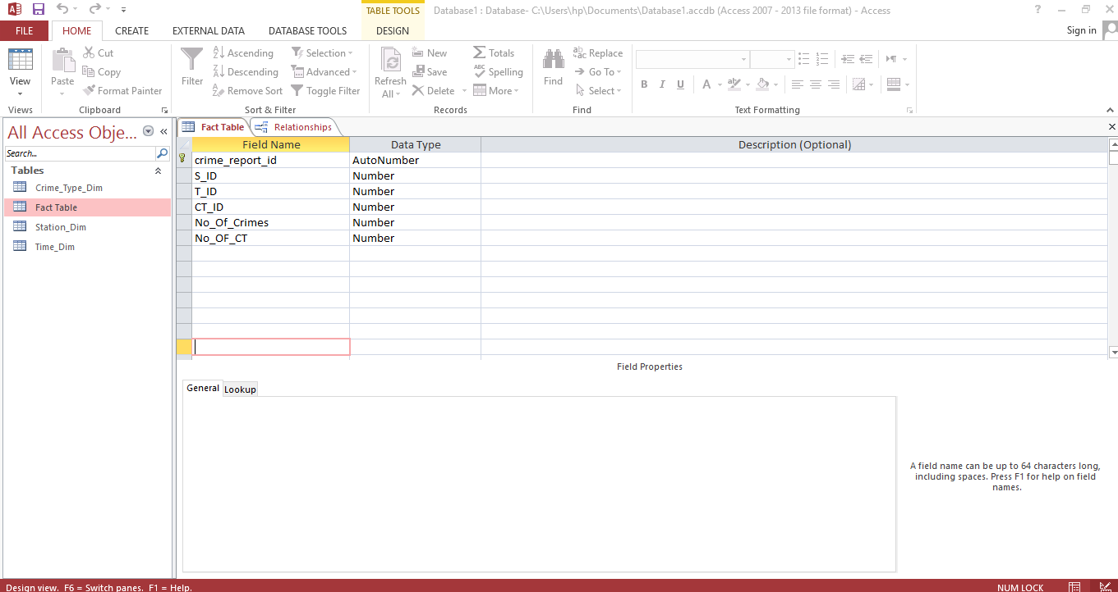

Relationship mapping in Ms Access

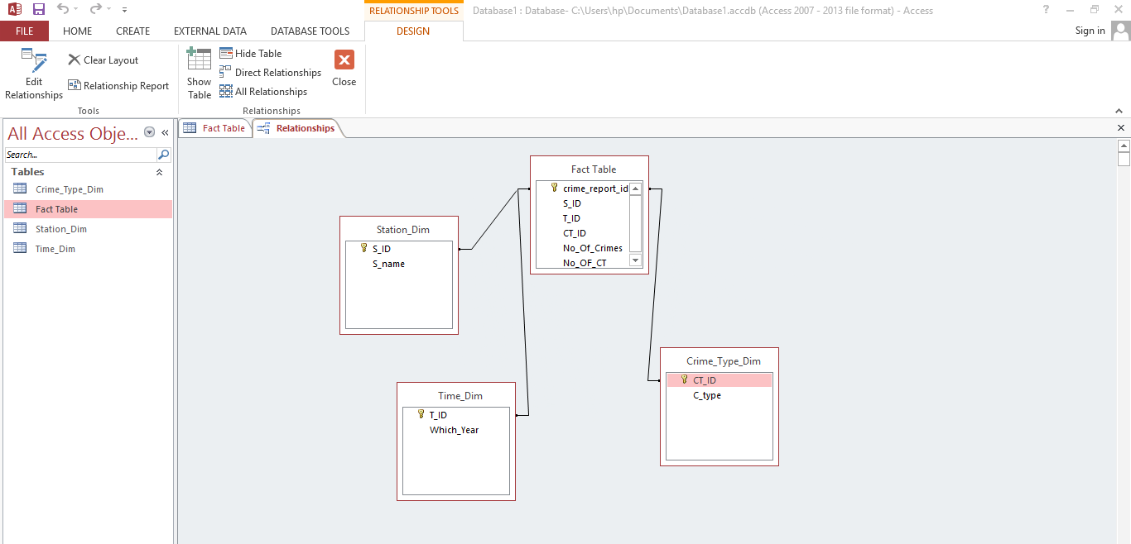

PIVOT in EXCEL
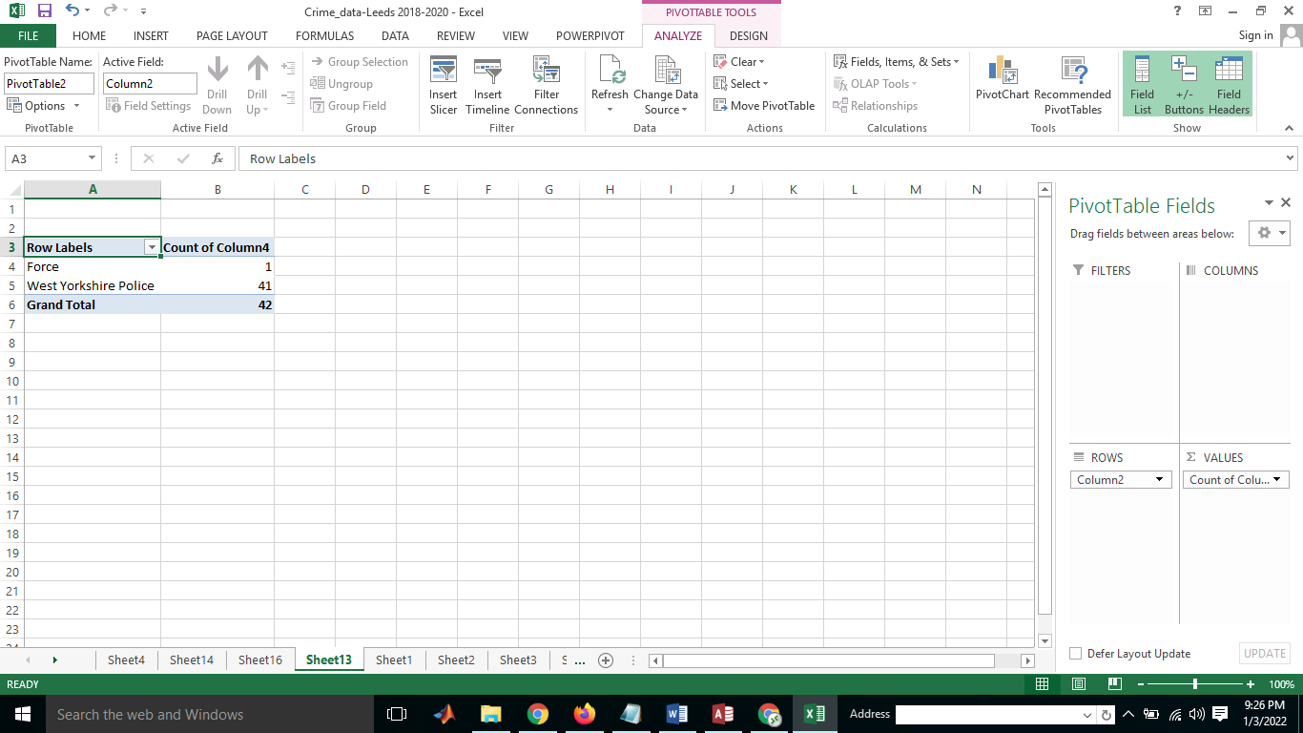

Literature Review
(Chenoweth, T., Corral, K 2006) data warehousing projection based on the data mart and its related technology to process the complex data warehousing query operation which has been analyzed and measured based on OLAP query structure and it process the largest operation to analyzed and measured the query. (Rahman, N., 2017) effective data ware housing approach is based on online data analytics tools & technique, which has been measured and predicted on query processing framework. The enterprise data warehousing projection based data mart which process the complex query operation that required by the client. The organization makes strategic business decision based on the data warehousing decision which extract and processed by the data mart. Motivation behind this studies scheme practically analyzed on ORACLE APEX tool various SQL query has been performed based on different database operation, data dimensional data has been created which associated with fact table of star schema design. In this studies fact table and dimensional data variable has been used to analyzed and process different OLAP query operation to take business and strategic decision to fulfill the business needs. TASK 3 – Findings and Reflection

Methodology
(Sen, A. Sinha, A.P., 2005) data warehousing methods (Aslam, T., 2020) data warehousing plays essential role for developing the organization business policies and boosting the business and employees growth level high due to online data analytics and machine learning method used by the data warehousing. Machine learning methods of logistic regression, naïve bays and support vector machine algorithm works effectively to mine the large dataset chunk and cubes and extract and analyzed the required data framework which required by the organization system. The development of data warehousing plays significant roles to coordinate time variation, nonvolatile assortment, and various data warehousing projections works online processing system. Client interface based on OLAP system, client can see related data cells by using the OLAP devices. Social database processed by the structured query language SQL operation. (Gardner, S.R., 1998) the data warehousing system design with the following steps:
- Determine business objective
- Collect and analyse information
- Identify core business process

Architecture

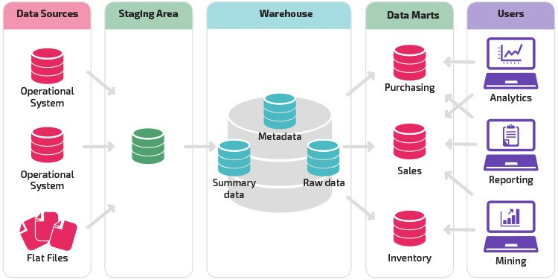

PAPA framework, Theory of Stakeholders

(Bole, U., Popovič, A Jaklič, J., 2015.) Data warehousing framework based on data mining and data mart technique, data mining approach design on mining algorithm for decision making strategies to process the large amount of data. Data mining approach considering best approach for data warehousing projection in which particular data and information presented from the large pool of data warehouse. (Ciampi, F., Demi, S., Papa, A., 2021) data mining operate and processed the largest query operation based on innovative business model, the relationship between novel data mining approach which based on business model.

Bibliography
Rahm, E. and Do, H.H., 2000. Data cleaning: Problems and current approaches. IEEE Data Eng. Bull., 23(4), pp.3-13.

Golab, L., Johnson, T., Seidel, J.S. and Shkapenyuk, V., 2009, June. Stream warehousing with DataDepot. In Proceedings of the 2009 ACM SIGMOD international conference on management of data (pp. 847-854).

Eckerson, W.W., 2002. Data quality and the bottom line. TDWI Report, The Data Warehouse Institute, pp.1-32.

Inmon, W.H., 1995. What is a data warehouse. Prism Tech Topic, 1(1), pp.1-5.

Gao, B., Zhang, S. and Yao, N., 2012, June. A multidimensional pivot table model based on MVVM pattern for rich internet application. In 2012 International Symposium on Computer, Consumer and Control (pp. 24-27). IEEE.

Chenoweth, T., Corral, K. and Demirkan, H., 2006. Seven key interventions for data warehouse success. Communications of the ACM, 49(1), pp.114-119.

Beath, C.M. Supporting the information technology champion. MIS Q. 15, 3 (Sept. 1991), 354--370.
Cooper, B.L., Watson, H.J., Wixom, B.H., and Goodhue, D.L. Data warehousing supports corporate strategy at First American Corporation. MIS Q. 24, 4 (Dec. 2000), 547--567.
Inmon, W.H., Imhoff, C., and Sousa, R. Corporate Information Factory. John Wiley, New York, 1997.

Rahman, N., 2017. An empirical study of data warehouse implementation effectiveness. International Journal of Management Science and Engineering Management, 12(1), pp.55-63.

Porter, J.D. and Rome, J.J., 1995. Lessons from a successful data warehouse implementation. Cause Effect, 18, pp.43-50.

Ariyachandra, T. and Watson, H., 2010. Key organizational factors in data warehouse architecture selection. Decision support systems, 49(2), pp.200-212.

Sen, A. and Sinha, A.P., 2005. A comparison of data warehousing methodologies. Communications of the ACM, 48(3), pp.79-84.

Aslam, T., 2020. A Comparison of Data Warehousing Methodologies.

Gardner, S.R., 1998. Building the data warehouse. Communications of the ACM, 41(9), pp.52-60.

Bole, U., Popovič, A., Žabkar, J., Papa, G. and Jaklič, J., 2015. A case analysis of embryonic data mining success. International journal of information management, 35(2), pp.253-259.

Ciampi, F., Demi, S., Magrini, A., Marzi, G. and Papa, A., 2021. Exploring the impact of big data analytics capabilities on business model innovation: The mediating role of entrepreneurial orientation. Journal of Business Research, 123, pp.1-13

Appendixes – add of your APEX code here

SQL Query Scripts

CREATE TABLE “TIME_DIM"
( "T_ID" NUMBER(*,0) NOT NULL ENABLE,
"WHICH_YEAR" NUMBER(*,0) NOT NULL ENABLE,
CONSTRAINT "PK_TIME_DIM" PRIMARY KEY ("T_ID")
USING INDEX ENABLE
)
CREATE TABLE "DRUGS"
( "DRUGS_ID" NUMBER(1,0),
"DRUGS_TOTAL" NUMBER(20,0),
"FORCE_" VARCHAR2(20),
"NEIGHBOUR" VARCHAR2(20),
PRIMARY KEY ("DRUGS_ID")
USING INDEX ENABLE
)
CREATE TABLE "FINANCIAL"
( "FINANCIAL_ID" NUMBER(8,0),
"FINANCIAL_YEAR" NUMBER(4,0),
"TOTAL_WALES_PER_CRIME" NUMBER(8,0) DEFAULT (0),
CONSTRAINT "PK_FINANCIAL_ID" PRIMARY KEY ("FINANCIAL_ID")
USING INDEX ENABLE
)
/

CREATE OR REPLACE EDITIONABLE TRIGGER "FINANCIAL_TRIG"
BEFORE INSERT ON FINANCIAL
FOR EACH ROW
BEGIN
IF :NEW.FINANCIAL_id IS NULL THEN
SELECT FINANCIAL_SEQ.NEXTVAL INTO :NEW.FINANCIAL_ID FROM SYS.DUAL;
END IF;
END;

/
ALTER TRIGGER "FINANCIAL_TRIG" ENABLE

CREATE TABLE "CRIME_REPORTER"
( "REPORTER_ID" NUMBER,
"REPORTER_NAME" VARCHAR2(35),
"ADDRESS" VARCHAR2(60),
PRIMARY KEY ("REPORTER_ID")
USING INDEX ENABLE
)
CREATE TABLE "CRIME_REGISTER"
( "CRIME_ID" NUMBER(4,0),
"CRIME_NAME" VARCHAR2(20),
"LOCATION_ID" NUMBER(8,0),
"REPORTED_DATE" DATE NOT NULL ENABLE,
"POLICE_ID" NUMBER(4,0),
"CRIME_STATUS" VARCHAR2(8),
"CLOSED_DATE" DATE DEFAULT NULL,
"REPORTER_ID" NUMBER(8,0),
"OFFICER_NOTE" VARCHAR2(128),
"CRIME_TYPE" VARCHAR2(15),
"LINKED_CRIME_ID" NUMBER(8,0),
"DETECTIVE_ID" NUMBER(8,0),
CHECK (crime_status in('OPEN', 'CLOSED', 'open','closed')) ENABLE,
CONSTRAINT "PK_CRIME_REG" PRIMARY KEY ("CRIME_ID")
USING INDEX ENABLE
)
/
ALTER TABLE "CRIME_REGISTER" ADD CONSTRAINT "FK_DETECTIVE" FOREIGN KEY ("DETECTIVE_ID")
REFERENCES "OFFICER" ("OFFICER_ID") ON DELETE CASCADE ENABLE
/
ALTER TABLE "CRIME_REGISTER" ADD CONSTRAINT "FK_CRIME_REG_LOC" FOREIGN KEY ("LOCATION_ID")
REFERENCES "LOCATION" ("LOCATION_ID") ON DELETE CASCADE ENABLE
/
ALTER TABLE "CRIME_REGISTER" ADD CONSTRAINT "FK_OFFICER" FOREIGN KEY ("POLICE_ID")
REFERENCES “OFFICER" ("OFFICER_ID") ON DELETE CASCADE ENABLE
/

CREATE OR REPLACE EDITIONABLE TRIGGER "CRIME_REGISTER_TRIG"
BEFORE INSERT ON CRIME_REGISTER
FOR EACH ROW
BEGIN
IF :NEW.CRIME_id IS NULL THEN
SELECT CRIME_REGISTER_SEQ.NEXTVAL INTO :NEW.CRIME_ID FROM SYS.DUAL;
END IF;
END;

/
ALTER TRIGGER "CRIME_REGISTER_TRIG" ENABLE
/ CREATE TABLE "CRIME_TYPE_DIM"
( "CT_ID" NUMBER(*,0) NOT NULL ENABLE,
"C_TYPE" NUMBER(*,0) NOT NULL ENABLE,
CONSTRAINT "PK_CRIME_TYPE_DIM" PRIMARY KEY ("CT_ID")
USING INDEX ENABLE
)
/ CREATE TABLE "CRIME_BURGLRY"
( "BURGLR_ID" NUMBER(1,0),
"BURGALRY_TOTAL" NUMBER(20,0),
"FORCE_" VARCHAR2(20),
"NEIGHBOUR" VARCHAR2(20),
PRIMARY KEY ("BURGLR_ID")
USING INDEX ENABLE
)
Describe burglary
Describe time_dim

select count(*)
from crime_register;

select sum(location_id)
from crime_register;

select avg(location_id)
from crime_register;

select max(location_id)
from crime_register;

select min(location_id)
from crime_register;

